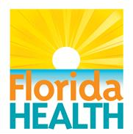

**VOLUNTEER HEALTH CARE PROVIDER PROGRAM**

**2025 FEDERAL POVERTY GUIDELINES – 300%**

|  |  |  |
| --- | --- | --- |
| **FAMILY SIZE** | **MONTHLY** | **YEARLY** |
| **1** | **$3,912** | **$46,950** |
| **2** | **$5,289** | **$63,450** |
| **3** | **$6,663** | **$79,950** |
| **4** | **$8,037** | **$96,450** |
| **5** | **$9,414** | **$112,950** |
| **6** | **$10,788** | **$129,450** |
| **7** | **$12,162** | **$145,950** |
| **8** | **$13,539** | **$162,450** |
| **For each additional person, add** | **$1,374** | **$16,488** |

|  |
| --- |
| **SOURCE: Federal Register: January 28, 2025** |
| **Compiled by Chris Gainous**  **Volunteer Health Services**  **Florida Department of Health** |
|  |
|  |